**Testing & Integration Plan**

FH Mobile Application

Version 1.0

Prepared by

Omar Rivera Andrew Poirier Daven Amin Rick Rejeleene

Table of Contents

1.0 Introduction 3

2.0 Modular Test 3

2.1 User Platform Requirements 3

2.1.1 Bullet/Table 1 – Title of Test Case 3

2.2 Account Requirements 3

2.2.1 Bullet/Table 1 – Title of Test Case 3

2.3 Workout schedule requirements 4

2.3.1 Bullet/Table 1 – Title of Test Case 4

2.4 Validation Requirements 4

2.4.1 Bullet/Table 1 – Title of Test Case 4

2.5 Server Platform Requirements 4

2.5.1 Bullet/Table 1 – Title of Test Case 4

2.6 Server Requirements 5

2.6.1 Bullet/Table 1 – Title of Test Case 5

2.7 User Account Requirements 5

2.7.1 Bullet/Table 1 – Title of Test Case 5

2.8 User Interface Requirements 5

2.8.1 Bullet/Table 1 – Title of Test Case 5

2.9 Database Requirements 6

2.9.1 Bullet/Table 1 – Title of Test Case 6

2.10 Performance Requirements 6

2.10.1 Bullet/Table 1 – Title of Test Case 6

# 1.0 Introduction

This document describes the test plan and integration for the FH mobile application.

# 2.0 Modular Test

This section is broken down in to the different modular that will be tested in this section

## 2.4 Validation Requirements -OX

### 2.4.1 Bullet/Table 1 – Title of Test Case

|  |  |
| --- | --- |
| Requirement Number | 3.2.4 |
| Requirement Name | Validation Requirements |
| Pre-conditions | The user most have authenticator privileges to mark metrics for another users |
| Procedures | 1. Using the provided GUI navigate to the authenticate workout routine screen using the available menu/tabs (see Figure 2.4.1-1Gui Menu/Tabs). 2. Select the user that you will validate (If multiple users are available), and complete the metric information of the workout routine. This will consist of entering amount of repetitions, activities, etc. 3. After entering all the required fields press the summit button at the end of the screen (See figure 2.4.1.-2Summit button). 4. Wait for the server to confirm the workout validation. |
| Post Conditions | The system will return the message: “Schedule workout routine validated” informing to the user the validation is completed. |
| Test Results | PASS/FAIL |



Figure 4.2.1-1 GUI Menu and Tabs



Figure 4.2.1-2-Submit Button

## 2.8 User Interface Requirements -OX

### 2.8.1- User Interface – GUI provided

|  |  |
| --- | --- |
| Requirement Number | 4.1-UI-1 |
| Requirement Name | User Interface – GUI provided |
| Pre-conditions | The user most have the application installed in the phone. |
| Procedures | 1. Using your Android phone, navigate through the multiple Android desktop to find the FH app Icon. 2. Once you find the FH Icon, selected and wait until the software loads. 3. If the application was installed correctly, the screen shall display a GUI interface for the user to interact with the app (See Figure 2.8.UI1 GUI). |
| Post Conditions | The GUI that can be controlled by the user will appear in the screen. |
| Test Results | PASS/FAIL |
|  |  |

### 

Figure 3-2.8.UI1 GUI

### 2.8.1 User Interface – Allow authorizing individuals to apply penalty or credit

|  |  |
| --- | --- |
| Requirement Number | 4.1-UI-3 |
| Requirement Name | User Interface – Allow authorizing individuals to apply penalty or credit |
| Pre-conditions | The user most be logged into the system. |
| Procedures | 1. Using the GUI tabs, Navigate to the user information screen. (See Figure 4.1-UI-3) 2. In the Trainer Field add the name of the person that you would like to have as a trainer. 3. Wait until the system confirms the trainer it’s associated with your account. |
| Post Conditions | The system will display a message that confirms the trainer it’s now associated with your account. |
| Test Results | PASS/FAIL/WHY |

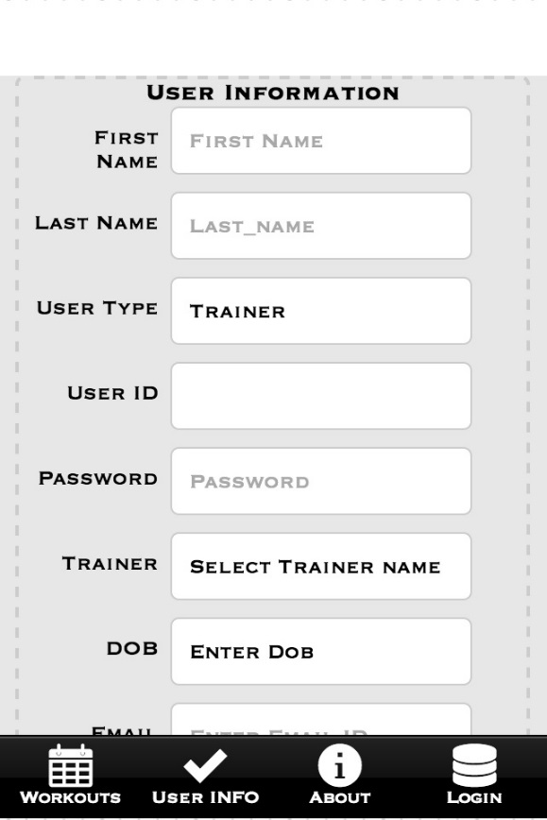

Figure 4.1-UI-3

### 2.8.1-UI-2 Bullet/Table 1 – Title of Test Case On Hold

|  |  |
| --- | --- |
| Requirement Number | Requirement No. From SRS |
| Requirement Name | Requirement Name |
| Pre-conditions | WHAT TEST NEEDS TO START OR HOW TO EXECUTE THE TEST |
| Procedures | 1. TESTING PROCEDURE 1 2. TESTING PROCEDURE 2 3. TESTING PROCEDURE 3 |
| Post Conditions | RESULTS FROM TEST |
| Test Results | PASS/FAIL/WHY |

## 2.10 Performance Requirements -OX

### 2.10.1 – Performance Requirements – Booting up/ Authenticate login

|  |  |
| --- | --- |
| Requirement Number | 5.1-1 |
| Requirement Name | Performance Requirements – Booting up/ Authenticate login |
| Pre-conditions | User most have an account in the system and the application installed.  Have a time measurements device available. (chronometer) |
| Procedures | 1. Open the application in your Android phone. 2. The first screen is the login screen, fill the user and password fields with your account information (NOTE: DO NOT PRESS LOGIN BUTTON YET) 3. Using your “Chronometer” select the mode that provides the best time resolution to measure seconds. 4. Press the chronometer start button and the application login button simultaneously to measure the authentication time. 5. Wait until the system logs you in and stop the chronometer   P.S: The system should log you in < 5 secs. |
| Post Conditions | The system will log you in and change to a screen different screen |
| Test Results | PASS/FAIL/WHY |

### 2.10.1 Performance Requirements – Retrieving Data and Application Reporting Back

|  |  |
| --- | --- |
| Requirement Number | 5.1-2 , 5.1-3 |
| Requirement Name | Performance Requirements – Retrieving Data and Application Reporting Back |
| Pre-conditions | User most have an account in the system and the application installed.  Have a time measurements device available. (chronometer) |
| Procedures | 1. Open the application in your Android phone. 2. In the user information screen fill the trainer field with valid information (NOTE: DO NOT PRESS SUMMIT BUTTON YET) 3. Using your “Chronometer” select the mode that provides the best time resolution to measure seconds. 4. Press the chronometer start button and the application summit button simultaneously to measure the system response time. 5. Wait until the system displays the message that confirms your information have been updated and stop the chronometer   P.S: The system should report back in < 5 secs. |
| Post Conditions | The system will log you in and change to a screen different screen |
| Test Results | PASS/FAIL/WHY |

## 9.99 System Integration

### 9.99.1– Integration Phase -1 – Testing system components independently

The first step of system integration will consist of making sure each one of the independent system components are working according to the required specifications. In the FH app this can be defined as having the main system components fully operational and tested independently before trying to integrate commence any interaction between the other components. The FH app phase-1 will validate have the necessary components to start with a formal system integration. In phase-1, we test the client application, the server application and the database independently, see Figure 4- System Integration Phase -1 System Components

Figure 4- System Integration Phase -1 System components



### 9.99.1– Integration Phase -2 – Data Base and Server Communications, Functionality and Performance

The Phase 2 of the system integration will consist of integrating the database system with the server system. As part of this phase, we will test the communications interfaces (Ethernet/Wireless) between the Database and the Server system. In addition, this phase includes testing the functionality and the interaction between the server and database. This will be performed using a PHP script to send a set of requests to the MySQL database from the server and receiving back the expected information, with the right format in the server system.



Figure 5- System Integration Phase -2 –Server and Database Integration

### 9.99.1– Integration Phase -3 –Client and Server Communications, Functionality and Performance

The Phase 3 of the system integration will consist of integrating the Android application with the server system. As part of this phase, we will test the communications interfaces (Ethernet/Wireless) between the Client Application (The Android operating system will provide the communication layer) and the Server system. In addition, this phase includes testing the functionality and the interaction between the client and server components. This phase will be tested using a client script application that will send and receive data objects as a JSON format from the server. The server must be able to receive data from the client to process it, this will be tested sending data from the client application processing it in the server and displaying the results (e.g sending a set of numbers to by sum from the client and using the server to perform the calculations). In a summary, the client most be able to perform read and write operation on the server and the server must be able to process the client request.

Figure 5-System Integration Phase 3 Client and Server Integration



### 9.99.1– Integration Phase -4 –Complete system Integration Communications, Functionality and Performance

The Phase 4 of the system integration will integrate the all the system components as a one whole system. In theory, this phase of the integration should represent the whole system as a system of systems. In the FH application case this will encompass the client application, server scripting and database queries and responses.

Figure 6--System Integration Phase 4 Complete System Integration

